**5**

**______________________________________________________**

**System Design**

1. **System Design & Methodology**
2. **Process Design**
   1. **System Design & Methodology**

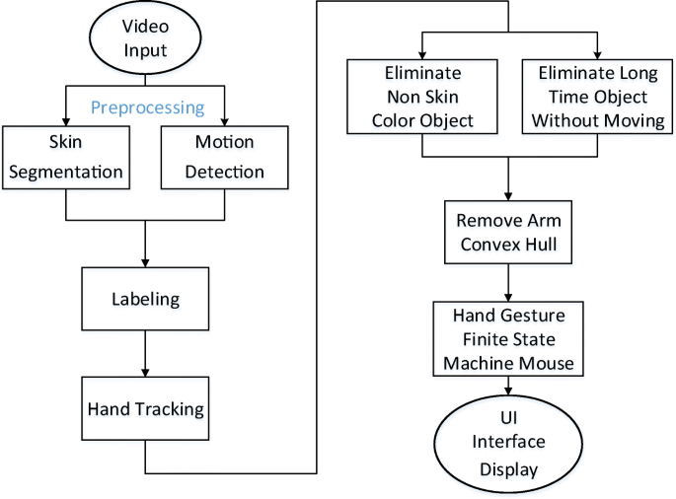

Fig 5.1.1 System Design

**Methodology**

The overview of the hand gesture recognition system (as shown in Fig. 5.1.2) consists of the following stages.

The first stage is the hand gesture image capture stage where the images are taken using digital camera under different conditions such as scaling, translation and rotation.

The second stage is a pre-processor stage in which edge detection, smoothing, and other filtering processes occur. In the next stage, the features of the images of hand gesture are extracted using two methods, namely, hand contour and complex moments.

The last stage is the classification using Artificial Neural Network (ANN), where the recognition rate is calculated for both hand contour-based ANN and complex moments-based ANN and comparison is carried out.

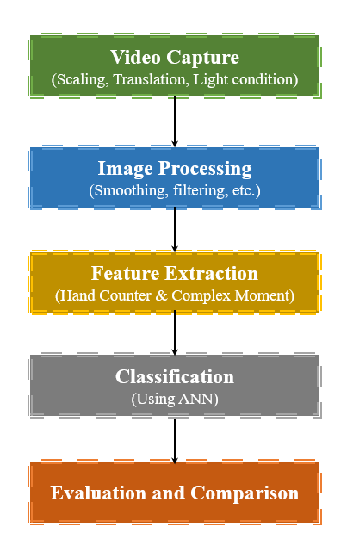

Fig 5.1.2 Methodology

* 1. **Process Design**

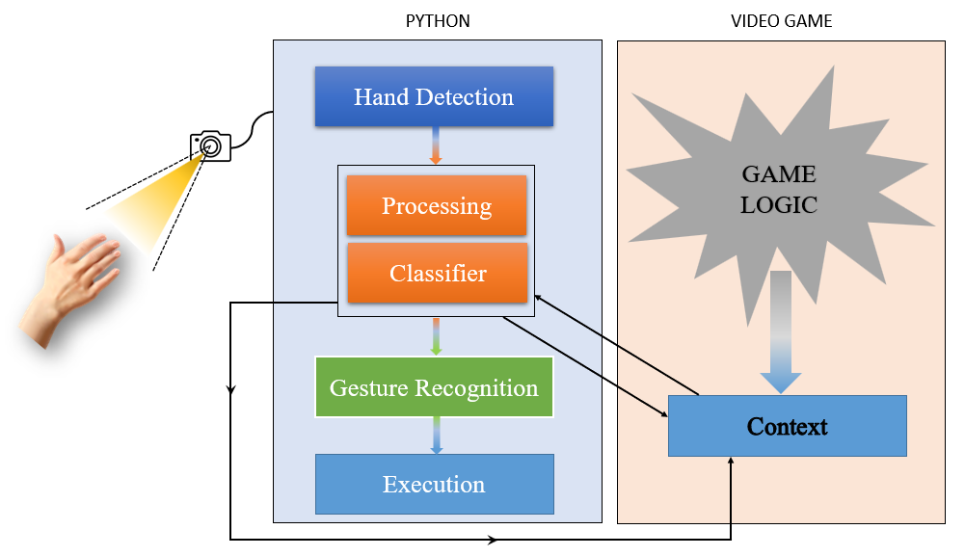

**Process:**

* It begins by taking video frames using a camera and processing them with OpenCV.
* The algorithm then uses Mediapipe to identify hands and carries out a number of operations, including hand tracking, obtaining landmarks, and converting frames, among others.
* The following stage uses a classifier to specify or recognize a gesture and includes the following crucial steps:
  + Data collection, preprocessing, and feature extraction
  + Train the model, validate it, and then deploy it.
* In essence, a classifier is a machine learning algorithm that is used to recognize new gestures in real-time and is trained on a dataset of various gestures.
* Finally, a gesture is recognized and carried out.
* This procedure is carried each time and continues until the user exits.